Rubric for Lab Work (5%)

LAB NO.: | 1:Threat Variance: Web Defacement | SEM/TRADE:
GROUP MEMBERS: | - ABDUL HARIZ BIN MOHD SARNUDIN | TTO: | Mohamad Aiman Hanif
GROUP MEMBERS: | - ABDUL HARIZ BIN MOHD SARNUDIN | MARKS: | /20

 |  | MARKS
No. | Criteria | NEEDS IMPROVEMENT [1] | APPROACHES EXPECTATIONS[2] | MEETS EXPECTATIONS [3] | EXCELLENT [4]
GROUP LABWORK |  |  |  |  |  | Marks
1. | Understanding on Topology of the scenario | Cannot develop understanding on the scenario topology | Able develop understanding on the scenario topology but still not accurate and detail | Clear, accurate understanding explanation of the scenario topology with diagrams and complete but with NO example | Clear, accurate understanding explanation of the topology with diagrams and complete example.
2 | Knowledge on lab objectives and concepts | Students failed to demonstrate  clear understanding of the lab objectives and  concepts. | Students demonstrates  some knowledge of the lab objectives and  concepts. | Student  demonstrates  sufficient level of the lab objectives and  concepts. | Student  demonstrates  well verse of the lab objectives and concepts.
3 | Lab completion | Not able to achieve any of lab objectives and show any output. | Able to achieve some lab objectives and show some output. | Able to achieve most of lab objectives and show most of the output. | Able to completely achieve all lab objectives and show all of the output.
4 | Interpreting Findings | Students failed to interpret the findings and result. | Student able to interpret some of the findings and result, but in a somewhat unclear manner. | Students able to interpret most of the findings and result. | Student able to interpret all the findings and result clearly and comprehensively.
5 | Level of Needed assistance | Student was unable to complete task with assistance. | Student was unable to complete task without major assistance. | Student was able to complete the task with little assistance. | Student was able to complete the task without assistance.
TOTAL MARKS: |  | /20

ASSESSOR COMMENT: | Good

Answer all questions:

- Explain the topology requirement of the lab. You may use diagram to support your explanation.
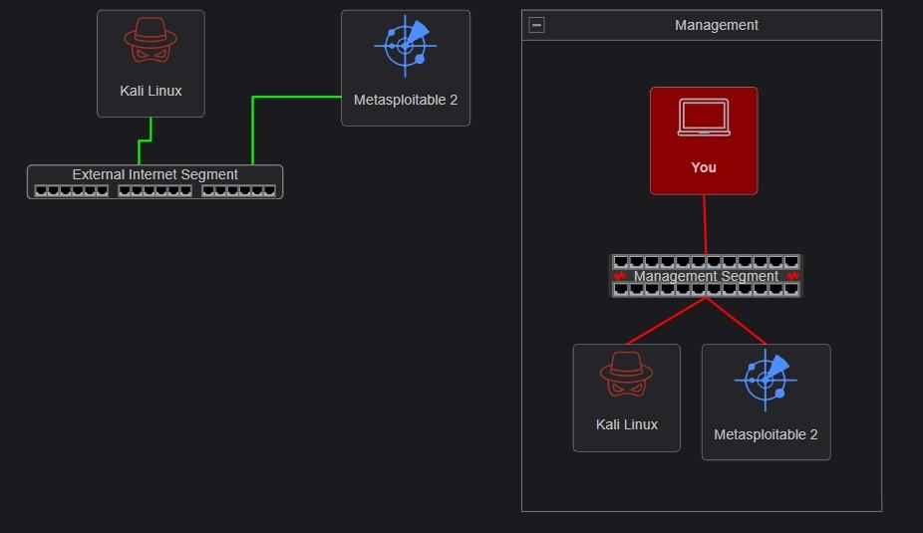

- Explain your expectation from this lab. What is your achievement before and after lab completion.

Expectation:
I expected to learn how web defacement happens in a real lab environment. I also expected to understand how attackers can change the content of a website and why this attack is dangerous.

Before Achievement:
Before doing this lab, I only knew that web defacement means changing a website’s page or appearance. I did not really understand how it works using a vulnerable web server.

After Achievement:
After completing this lab, I understood how a vulnerable website can be accessed and modified. I also learned that web defacement can affect the integrity and reputation of a website. This lab helped me understand why web applications need proper security, strong access control, and regular monitoring.

- Did you able to complete the lab successfully (YES/NO)? Explain why and how. Demonstrate and explain the output you achieve from this lab.

Yes, I was able to complete the lab successfully.

The lab was successful because I was able to access the vulnerable Online Banking System website and view the defaced result. The original website page was changed and a defacement message appeared on the page. This shows that the website was vulnerable and the lab activity worked.

The lab question asks us to explain whether the lab was completed successfully an

- Interpret the result and your findings? You explanation may include the way of mitigation as well.



